**Project Report**

**on**

**Quiz App with HTTP REST API**

**Submitted To**

**Maharishi Markandeshwar (Deemed to Be University)**

In partial fulfillment of the requirement of

BCA 5rth Sem Examination

Under the guidance of

Dr. Pooja Rani

Professor (Assistant),

Submitted by

Ashif Ali 1319075

Anup Kumar Sah 1319073

Khushbu Kumari 1319066

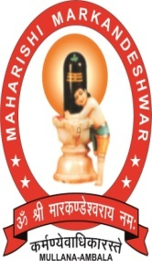

**M.M. INSTITUTE OF COMPUTER TECHNOLOGY & BUSINESS MANAGEMENT**

**MAHARISHI MARKANDESHWAR (DEEMED TO BE UNIVERSITY)**

**MULLANA–AMBALA, HARYANA (INDIA) - 133207**

**(Established under Section 3 of the UGC Act, 1956)**

**(Accredited by NAAC with Grade ‘A’)**